****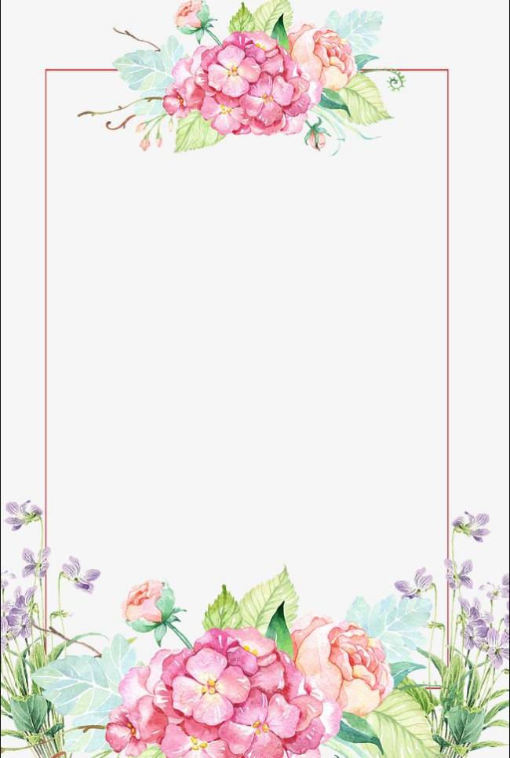

**Flower Arranging**

Join us for our 3 week course of flower arranging.

Suitable for all capabilities

**Week 1 -Friday 17th November-**

A basic flower Arrangement (materials £5 extra)

**Week 2- Friday 24th November**

Christmas Table Arrangement (materials from £5 extra)

**Week 3- Friday 8th December**

Christmas door wreath (materials from £5 extra)

**If possible can you provide your own greenery and foliage.**

1.00-3.00pm

£3.50 per session

**LifeTime, 101 Sankey Street, Warrington,**

**WA1 1SR**